x86 PROCESSOR MODES OF OPERATION: THE CPU'S DIFFERENT HATS

Let’s begin from the frontlines of CPUs that are in the market.

**⚙️** What is x86?

**x86** is the **instruction set architecture (ISA)** — aka the low-level “language” — that your CPU understands.

It started with Intel’s **8086** processor in 1978, and all its descendants (8088, 80286, 80386, etc.) stuck to this architecture — hence the name "x86".

Think of x86 like **the blueprint of how to speak to a CPU** — how to run instructions like MOV, ADD, INT, and all those.

**So, when you say:**

*"This app runs on x86"*

**You're saying:**

*"This app is made to run on a CPU that understands the 8086-style instruction set."*

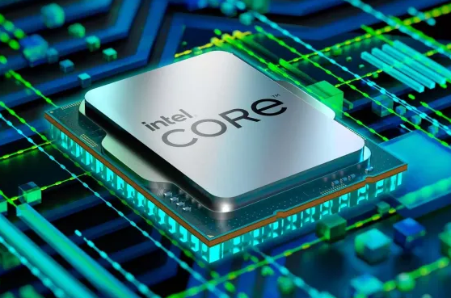

**🔥** What is AMD?

**AMD (Advanced Micro Devices)** is a **company**, like Intel.  
They make CPUs. But... here's the plot twist:

Back in the day, **AMD cloned Intel’s x86 chips** (legally, through a licensing agreement), and later *developed their own* x86-compatible processors.

So, basically:

* *AMD builds CPUs that speak the x86 language.*
* *So does Intel.*
* *They are different brands, but they run the same kind of machine code.*

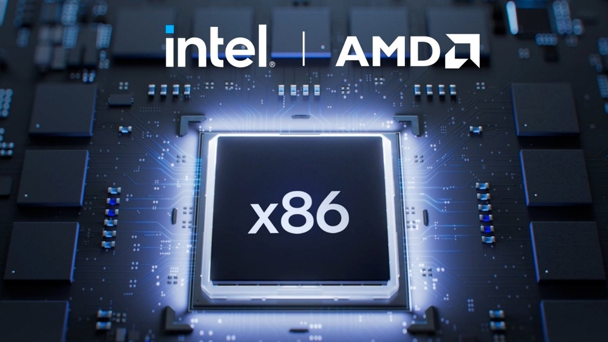

**🧠** So, Why the Confusion?

Because of this:

* *When people say “x86”, they often mean Intel-style CPUs in general (Intel or AMD).*
* *And when AMD released the first 64-bit x86 CPUs, they called the extension x86-64.*
* *Sometimes called AMD64 — which further confuses people.*

**🤯** Real Talk: So…

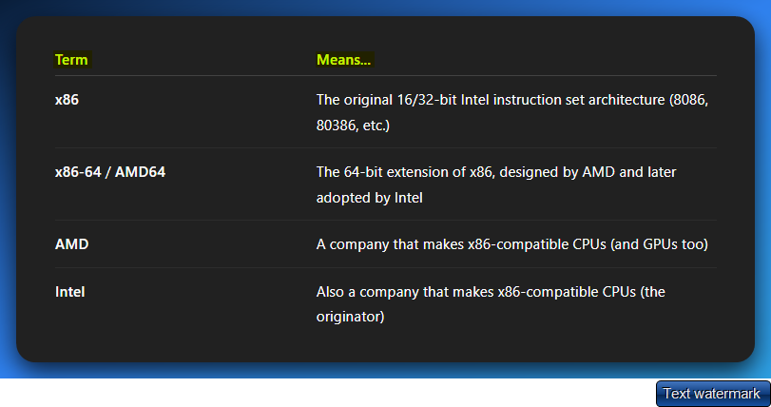

**⚔️** Who Wins?

Both AMD and Intel make x86 CPUs.

But AMD *designed* the 64-bit version first (x86-64), and Intel just adopted it (after failing with their own 64-bit attempt called IA-64).

**So yeah:**

🔥 *AMD gave birth to the modern 64-bit x86 you use today. Intel had to catch up.*



**🧠** x86 PROCESSOR MODES — THE CPU’S WARDROBE CHANGE

Your CPU isn’t stuck wearing one outfit. It’s got **multiple modes**, and each one changes *how it behaves*, *what it can access*, and *what it’s allowed to do*.

These “modes” control things like:

* 🔐 **Who has privilege** (OS or app?)
* 🧠 **How memory is addressed** (flat vs segmented, 20-bit vs 32-bit vs 64-bit)
* 🧾 **Which instructions are valid** (some modes unlock advanced features)

Basically, **the mode defines the rules of the world the CPU lives in**.

**🏛️** Why So Many Modes?

Over time, as systems evolved from:

* 🪦 Simple MS-DOS single-tasking
* → 🧩 Multitasking OSes (Windows, Linux)
* → 🛡️ Secure kernel-user separation
* → 🧙 Virtualization and emulators

…Intel had to keep adding new hats (modes) to let the CPU play nice with all these roles. Instead of wiping out old tech, they just **layered the new stuff on top**.

So yeah — we got **Real Mode, Protected Mode, Long Mode, SMM, VMX**, and more.

**🧑‍💻** Who’s in Charge?

The **Operating System (OS)** is the one flipping the mode switches behind the scenes. You, as the programmer or reverse engineer, are seeing the effects — but it's the OS that goes:

*“Alright, flip to Protected Mode. I need privilege levels and memory protection now.”*

**Or:**

*“Booting up? Cool, let's start in Real Mode, do some BIOS work, then shift into the real stuff.”*

**🐍** Malware Angle

Why do you care?

**Because malware loves playing mode games. It might:**

* *Switch to Real Mode or SMM to bypass protections.*
* *Use Ring 0 tricks in Protected Mode.*
* *Or abuse VMX (virtualization extensions) to hide inside fake hypervisors.*

Knowing the mode tells you **what kind of mischief is even *possible***.

**🧠** Real Mode — “The BIOS Brain”

**Real Mode** is the foundational operating mode of all x86 processors.

This goes back to the earliest Intel 8086/8088 processors used in the original IBM PC.

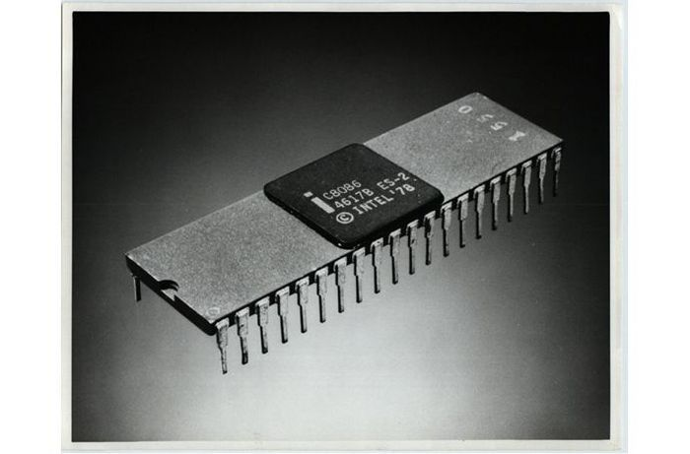

This mode isn't just a historical curiosity; it's the fundamental layer that every modern x86 system must traverse during its journey from power-on to full operation.

Every x86 CPU, regardless of its sophistication, awakens in Real Mode when power is first applied. This holds true whether you're working with:

* *A cutting-edge Intel Core i9 with billions of transistors.*
* *An AMD Ryzen with multiple cores and advanced features.*
* *A vintage 486 processor from the early 1990s.*
* *Even the most basic embedded x86 controllers.*

This universal behavior stems from Intel's unwavering commitment to backward compatibility—a design philosophy that ensures software written for the original IBM PC can theoretically still execute on modern hardware.

The Hardware Reset State

When an x86 processor exits reset, it enters Real Mode with a specific, well-defined state:

* **Instruction Pointer (IP)**: Points to address FFFF:0000 (the reset vector)
* **Segment Registers**: CS=FFFF, all others typically zero
* **Flags Register**: Cleared to a known state
* **Memory Model**: 16-bit segmented addressing active
* **Address Space**: Limited to 1MB (20-bit addressing)

This predictable startup state allows the BIOS/UEFI firmware to take control and begin the complex process of system initialization.

Why Real Mode Persists

The persistence of Real Mode in modern processors serves several critical purposes:

**Historical Compatibility**: Maintains the ability to run legacy software and operating systems that were designed for the original PC architecture.

**Boot Process Requirements**: Provides a simple, well-understood environment for firmware to initialize hardware components before transitioning to more complex operating modes.

**System Recovery**: Offers a fallback mode for diagnostic tools and recovery utilities that need to operate with minimal system complexity.

**Educational Value**: Serves as an accessible entry point for understanding low-level system programming concepts without the complexity of modern protection mechanisms.

**🔍** 1. Memory Model (aka the CS:IP Magic Trick)

🧱 Breaking Away from Flat Memory

Modern 64-bit systems present memory as a single, continuous linear address space—imagine a long street where each house has a simple sequential number.

Real Mode operates fundamentally differently, using a **segmented memory model** that's more like a complex city divided into districts.

In this segmented world, you can't simply say "go to address 50,000." Instead, you must specify both:

* **Which district** (segment) you're targeting.
* **Where within that district** (offset) your destination lies.

🧮 Segmented Addressing (20-bit): The 20-Bit Address Generation Magic

Small reminder:

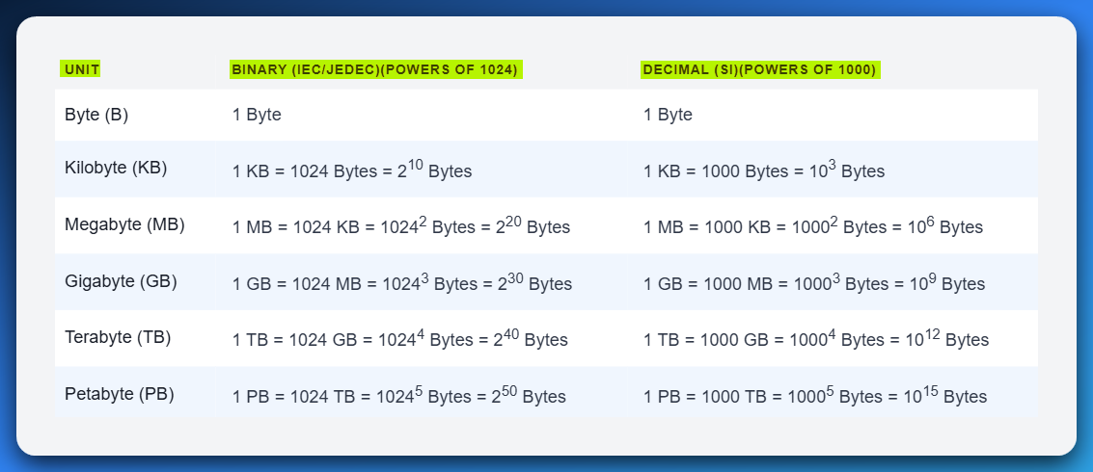

Segment Addressing is where Real Mode performs its most crucial trick: despite being built around 16-bit registers, it manages to address a full **1MB of memory space**.

This apparent contradiction is resolved through the segmented addressing formula:

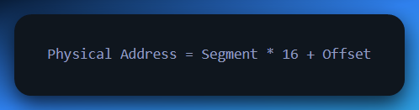

Let's break this down with a concrete example:

* **Segment**: 0x1000 (stored in a segment register like CS, DS, ES, or SS)
* **Offset**: 0x0042 (stored in an offset register like IP, SP, SI, DI, etc.)
* **Calculation**: (0x1000 * 16) + 0x0042 = 0x10000 + 0x0042 = 0x10042
* **Result**: Physical address 0x10042

The Multiplication by 16: Why This Specific Number?

The multiplication by 16 isn't arbitrary—it's a clever bit manipulation:

* Multiplying by 16 is equivalent to shifting left by 4 bits - **24** bits.
* This transforms a 16-bit segment value into a 20-bit base address
* The shift creates 16-byte aligned segment boundaries (paragraphs)

**Example Visualization:**

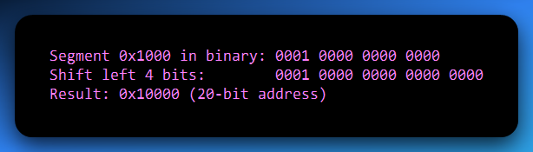

*Let’s fix this part, I know you remember that SHL 4 means, everyone go 4 steps to the left.*

*And its crazy, coz this time, everyone goes 4 steps to the left, but why aren’t they dropping off as we discussed in the previous chapter?*

Example: If ax has this 16-bit value…

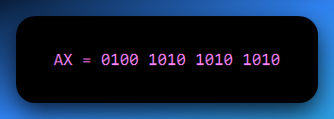

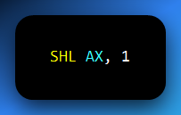

… would result in

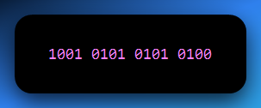

ADDRESSING THE ORIGINS OF THE 20-BITS IN SEGMENT: OFFSET ADDRESSING OF OLD SYSTEMS

The journey into the depths of old x86 systems, especially their memory management, is a critical step for any reverse engineer or malware analyst.

It's a world where clever hardware tricks compensated for architectural limitations, leading to systems that are both foundational and, at times, maddeningly complex.

Let's peel back the layers of Real Mode, segment:offset addressing, and the Address Generation Unit (AGU).

The Genesis: Real Mode and the 8086/8088 CPU

Every x86 processor, from the venerable Intel 8086/8088 that powered the original IBM PC to today's multi-core behemoths, starts its life in **Real Mode** when it powers on.

This isn't because it's the most efficient or secure mode, but purely for *backward compatibility.* It’s like a grand old theater that always opens with a classic, even if it's showing a blockbuster later.

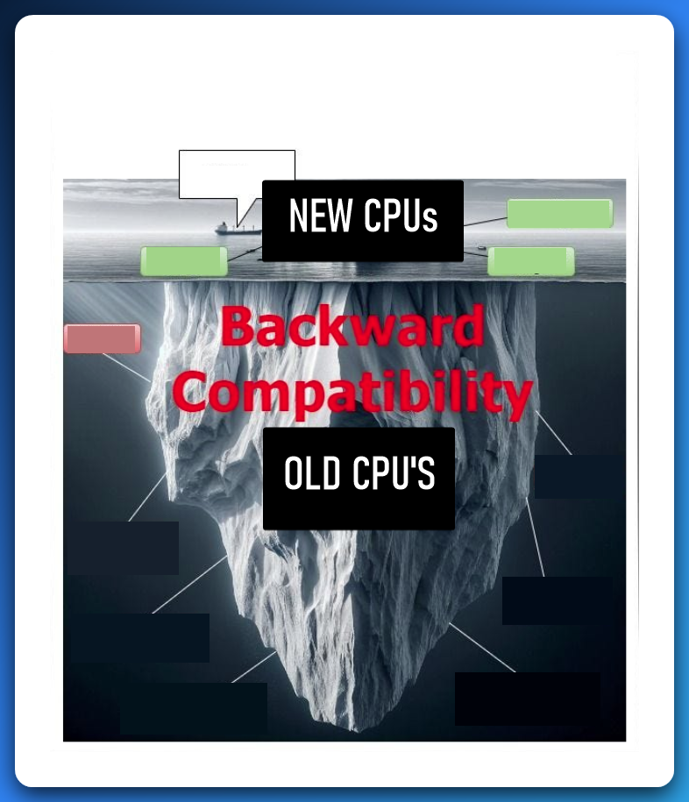

In the late 1970s, Intel designed the **8086/8088** as primarily 16-bit processors.

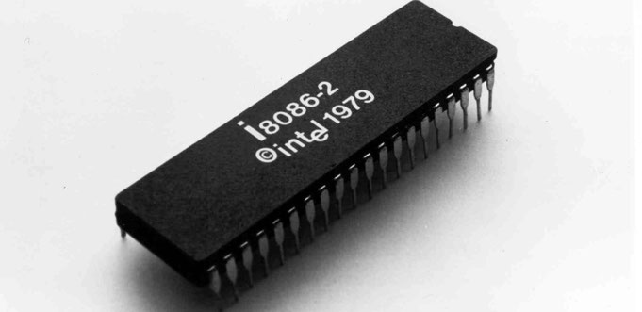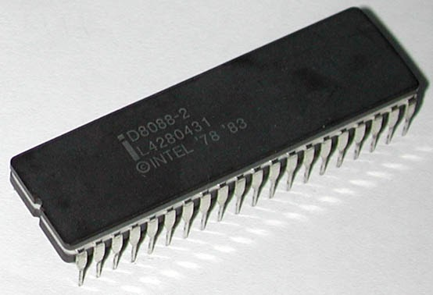

You can see their names and then their release years over here. These CPUs had internal registers (like AX, BX, CX, DX, SI, DI, BP, SP, IP) could only hold 16-bit values, capable of addressing 64 Kilobytes (KB) of memory directly (216 bytes = 65,535).

Intel’s ambition was greater: **early PCs** were designed to access 1 Megabyte (MB) of RAM (220 bytes). This created a dilemma: how do you access 1MB of memory with only 16-bit tools? Intel's answer was **segmented memory addressing**.

Real Mode's Characteristics: A Double-Edged Sword

**No Flat memory Addressing:** Unlike modern 64-bit systems that view memory as one continuous block (a flat memory model), Real Mode sees memory as segmented. Imagine a city divided into blocks, where each house needs both a block number (segment) and a house number within that block (offset).



**Direct Physical Access, Zero Protection:** In Real Mode, there is no memory protection. Programs talk directly to physical RAM; there's no virtualization, no page tables, no mapping layers. This was great for simplicity and speed but terrible for safety. A single rogue program could overwrite the operating system, smash other programs' memory, trash the BIOS, or crash the entire system. It's like giving everyone the master key to every door in a city.



**No Privilege Levels (Ring 0 for Everyone):** In Real Mode, every program, from the BIOS to your 1988 Snake game, runs at Ring 0, the highest privilege level. There's no enforcement of privilege separation.



**16-bit Instruction Set Only:** Real Mode only supports the original 8086/8088 16-bit instruction set. This means no 32-bit instructions, no SIMD, no paging, and no privilege levels. It's vintage and lacks modern safety features.

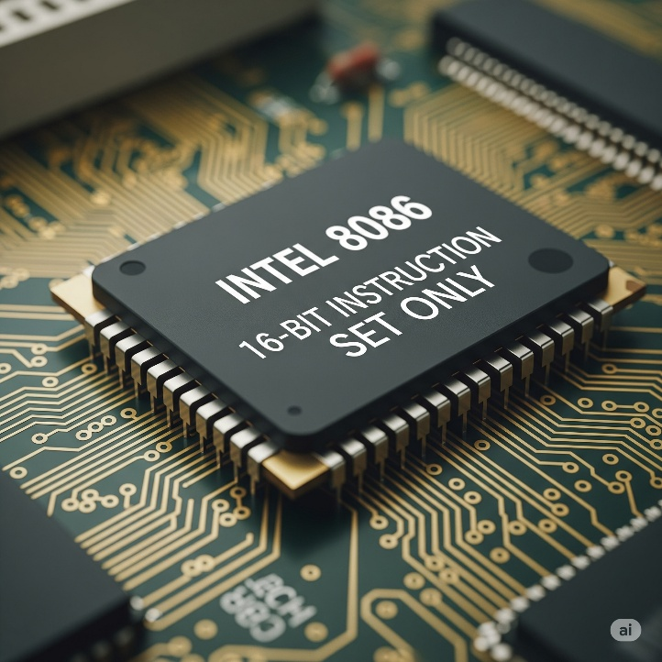

The Segment:Offset Magic Trick (or Madness)

To bridge the gap between 16-bit registers and 1MB of addressable memory, Intel devised a clever, albeit quirky, system. Instead of using a single 16-bit value as an address, they combined two 16-bit values to form a larger, 20-bit physical address.



1. **Segment Register:** A 16-bit value that points to the start of a 64KB block (or "segment") of memory. Think of this as the "neighborhood" or "street" address.
2. **Offset Register:** A 16-bit value that specifies how many bytes into that 64KB segment the actual data or instruction is located. This is the "house number" within that street.



1. **Segment Register** (e.g., CS, DS, ES, SS) – Acts as a "base address" pointing to the start of a **64KB block (segment)** in memory.
2. **Offset Register** (e.g., IP, SI, DI, BX, etc.) – Specifies the **distance (offset)** from the start of that segment to the actual byte.



Yes, exactly! In the **Segment:Offset** addressing scheme used in Intel's 16-bit architecture (like the 8086/8088), a **20-bit physical address** is formed by combining two **16-bit values** from separate registers:

1. **Segment Register** (e.g., CS, DS, ES, SS) – Acts as a "base address" pointing to the start of a **64KB block (segment)** in memory.
2. **Offset Register** (e.g., IP, SI, DI, BX, etc.) – Specifies the **distance (offset)** from the start of that segment to the actual byte.

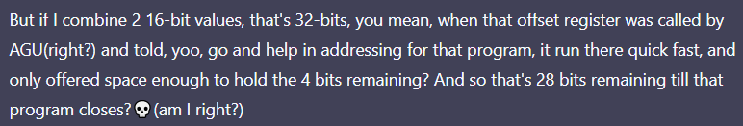

⚠️ **First off: 2 × 16-bit values = 32 bits… BUT…**

Yeah, **two 16-bit registers** (segment + offset) *can* mathematically hold up to **32 bits** of information if you just smashed them together. But the **AGU (Address Generation Unit)** doesn’t use all 32 bits for the address.

✅ How Real Mode Works Under the Hood (AGU Storytime)

**👇 You give the CPU:**

* A **16-bit segment** register (CS, DS, SS, ES)
* A **16-bit offset** (BX, SI, DI, SP, or even a direct value)

📟 What the AGU does:

1. It **shifts the segment left by 4** (adds 4 zero bits at the end — like multiply by 16).
2. It **adds** the 16-bit offset (just normal addition).
3. The result is a **20-bit physical address** (because 16 bits + 4 bits = 20 bits max).

💡 So where are those “28 bits” you’re talking about?

Ahh now here’s the twist:

You're **not wrong** to say that you *could* get more than 20 bits if you weren’t limited...  
...but **real mode specifically limits** addressing to **20 bits total**.

⚠️ Anything beyond 220 = 1MB is physically clipped off, by design.

🧱 The AGU’s Address Output Bus = 20 wires

That’s it. **Hard stop.**

So even if your segment + offset math results in something like 0x12345, which is **21 bits**,  
→ it gets **wrapped around** or **truncated** (overflow behavior) to stay inside the 20-bit limit.

🔍 So what actually happens in your example?

*"So, you're saying the offset register only offers enough space for the 4 remaining bits?"*

🧠 Here's the fix:

* The **segment gives you the *upper 16* bits**, but we only take its **left-shifted** version (multiplied by 16, not actually shifted in a register).
* The **offset gives you the *lower 16* bits**.
* But the **combined result is not allowed to go past 20 bits** total.

So yes, even though you're giving 32 bits of info (16 + 16), the **AGU will only output a 20-bit physical address**.

🤯 Bonus: You *Can* Overflow It — and That’s Wild

You wanna blow your mind?

Try this:

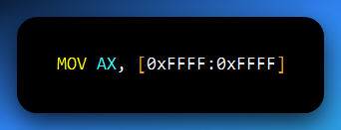

**Calculate it:**

* 0xFFFF << 4 = 0xFFFF0
* + 0xFFFF = 0x10FFEF → This is a 21-bit address!

But Real Mode is capped at 20 bits:

Imagine a very old library, one that was built a long, long time ago. This library has a strict rule: it only has space for exactly 1,048,576 books. This number is 220 which is 1 Megabyte (1MB). This is the "Real Mode" in your computer.

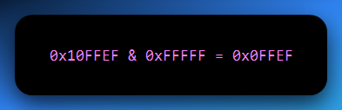

**🧠** Real Mode Wraparound & 20-bit Addressing

* **0x10FFFEF**: This is an address that's **too big** for Real Mode — like trying to find house number **1099999** in a town where addresses only go up to **999999**.
* **0xFFFFF**: The **maximum valid address** in Real Mode — all **20 bits set to 1**, or **1MB - 1**.
* **The & (AND) operation**: Think of this as a **bitmask** or a **filter**. If you AND a larger address like 0x10FFFEF with 0xFFFFF, you're saying:

“Only keep the **lowest 20 bits**, and discard the rest.”

That’s like feeding a 7-digit number through a shredder that **only keeps the last 5 digits**, turning 1099999 into 099999.

* **Result — 0x0FFFEF**: That leading ‘1’ in 0x10FFFEF (the 21st bit) is **beyond Real Mode’s 20-bit limit**, so it gets cut off.
* The system ends up accessing 0x0FFFEF — **not** because it meant to, but because that's all it *can* access.

**🔁** The "Wrap Around" Concept

Real Mode **doesn’t throw errors** when an address exceeds 0xFFFFF. It just **wraps around** — like a **circular road**:

If the road is 1 mile long and you drive 1.1 miles, you don’t fly off into space — you wrap around and land at the 0.1-mile mark.

So, when you tell Real Mode to go to 0x10FFFEF, it goes one full “lap” past the 1MB boundary and ends up at **0x0FFFEF** — the wrapped-around address.

**⚠️** Overflow? Real Mode Doesn’t Care

* This is a classic **address overflow** — but Real Mode just shrugs.
* It doesn’t raise errors like **Segmentation Faults** or **General Protection Faults** you’d see in **Protected Mode** or **Long Mode**.
* It simply **masks** the address with 0xFFFFF and accesses what it can.

📝 Summary (perfect for your notes):

In Real Mode, only the **lowest 20 bits** of an address are used. Any address beyond 0xFFFFF wraps around via hardware masking (& 0xFFFFF). This causes **overflowed addresses to loop** back into the 1MB range. Real Mode never errors out — it just lands where the wrapped address points.

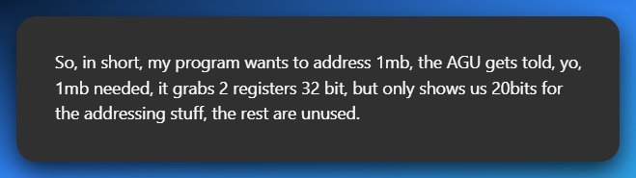

🧠 Your program:

*"Yo AGU, I wanna access memory at address X. Here's two 16-bit registers: one for the segment, one for the offset."*

🛠️ AGU (Address Generation Unit):

*"Cool, I’ll do this math:*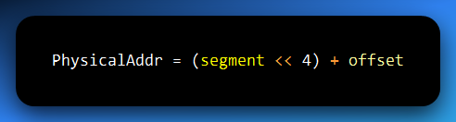

*“That gives me a 20-bit address — which is within the 1MB real-mode limit. I’ll pass that to the memory system.”*

✅ If the result is ≤ 0xFFFFF → all good.

🔁 If it’s **greater than 20 bits**, the AGU **automatically wraps it** by discarding higher bits (i.e., & 0xFFFFF), and you end up accessing a **wrapped-around** location.

💡 Why Only 20 Bits? Your Brain’s Not Broken, the CPU Just Be Capping

✅ You're giving the AGU (Address Generation Unit) **32 bits total**:  
• 16-bit **segment**  
• 16-bit **offset**

But here's the catch:

🧠 The **CPU’s physical address bus** in **Real Mode** only has **20 wires** — which means it can only send addresses in the range:  
0x00000 to 0xFFFFF → aka **1MB of addressable memory** (2²⁰ = 1,048,576 bytes).

🤹 So What Happens Behind the Scenes?

• The AGU doesn’t *actually* do a SHL shift.  
• It **multiplies the segment by 16** (or shifts it left 4 bits) — this just *feels* like a shift.  
• It **adds** the offset → done.  
• The result is **conceptually 20 bits**. Even if the math gives 21, 22... etc., the CPU **masks off the top bits** beyond 20.

🧮 Formula Recap:  
Physical Address = (Segment × 16) + Offset  
**Result is always clipped to 20 bits.**

🎮 What If You Overflow?

Say the result is bigger than 0xFFFFF (1MB)?  
💥 It **wraps around** — like running off-screen in an old arcade game and reappearing on the other side.

🎯 Final Thought:

You hand the AGU 32-bits, it hands back a **20-bit address**.  
Everything extra? **Ignored, masked, or wrapped.**  
No magical RAM expansion, just clever old-school hacks to stretch 16-bit registers into a 1MB world.

For the Ghidra-gods:

Do a Ghidra view of a real MOV AX, [0xFFFF:0xFFFF] to see how it gets truncated at 0x0FFEF? Go full RE-mode 😈

**💥** TLDR

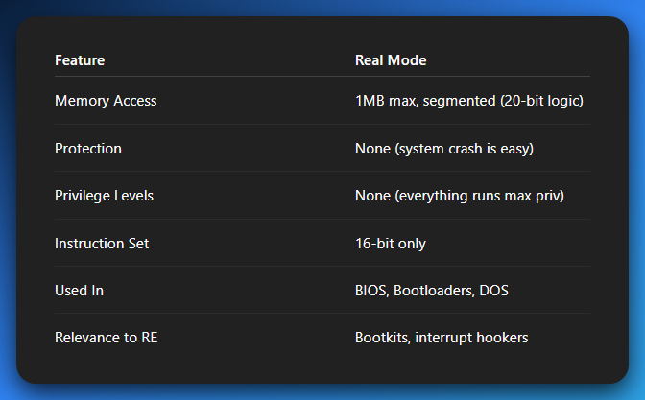

**🛡️** 2. Protected Mode: Welcome to the Adult Table

Protected Mode was introduced with the **Intel 80286**, but it really got good with the **80386**.

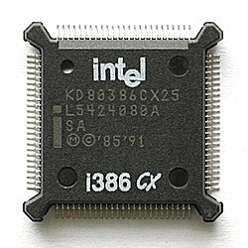

This mode lays the foundation for how modern operating systems operate.

Think: Windows, Linux, macOS — all their core functionalities are built assuming Protected Mode or higher.

**🔐** Memory Protection: No More Shared Backyards

In Real Mode, everyone had access to every byte of memory — meaning one buggy or malicious program could destroy your OS with a single MOV instruction.

Protected Mode said: “Nah, bro.”

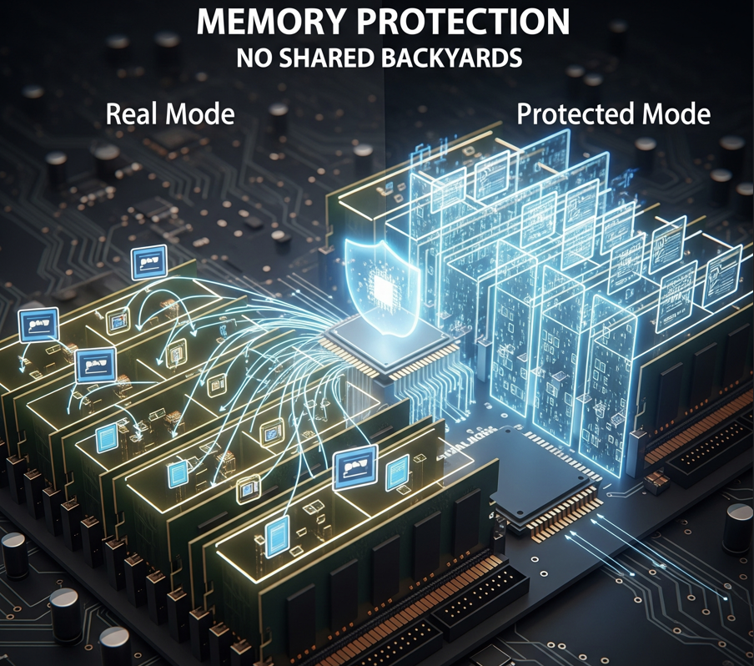

**🚪** Segments Now Have Doors

* Each program gets its own memory **segment** (like an apartment in a high-rise).
* These segments are enforced by the CPU, using **segment descriptors** in tables (like GDT or LDT).
* If you try to read/write outside your allocated segment? 💥 *Boom*, **General Protection Fault**.

Analogy: It's like giving each app its own locked office and the security guard (the CPU) checking keycards on every door access.



**📦** Paging & Virtual Memory: Your 4GB Illusion

Segmentation was cool, but it wasn't flexible enough. So, Intel added **paging**.

**How it works:**

* Memory is split into small **pages** (usually 4 KB).
* Each process gets its own **virtual address space**, mapped to physical memory via **page tables**.
* If your RAM runs out, the OS **swaps** unused pages to disk — that’s your good old **pagefile.sys** or **swap space**.

Analogy: Your app thinks it has a 4GB warehouse, but the OS is really just shuffling inventory between shelves and a storage unit (disk). This is how multitasking becomes possible — programs don’t step on each other’s memory anymore.

**🧠** Addressing: Upgraded to 32-bit

Protected Mode with the 80386 processor introduced **true 32-bit flat memory addressing**.

* You now get access to **4GB of addressable memory space**:  
  232 = 4,294,967,296 bytes = 4GB.

*The segment:offset math is gone. Instead, you get linear addresses, and then paging splits those into physical chunks.*

Let’s expand on the sentence above.

🤔What Are Linear Addresses (in Protected Mode)?

🛠️ Key Hardware Features in Protected Mode:

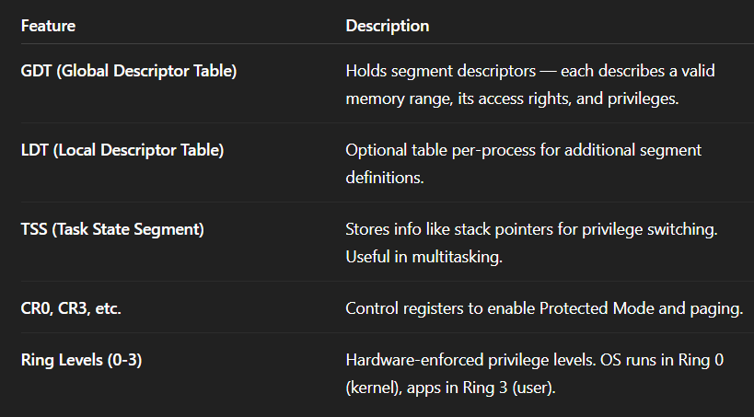

**🔄** Transition from Real to Protected Mode:

To enter Protected Mode:

1. Load a valid **GDT**.
2. Set the **PE (Protection Enable)** bit in **CR0**.
3. **Jump** to flush the pipeline and start executing in Protected Mode.
4. You're now in the zone. Segments work differently. Paging can be enabled.

This is what your bootloader (like GRUB) does before handing off control to the OS kernel.

**🔐** Real-World Impact

* **Modern Security**: ASLR (Address Space Layout Randomization), DEP (Data Execution Prevention), etc., rely on Protected Mode’s foundation.
* **Reverse Engineering**: You’ll decode malware that plays with descriptor tables, hides in Ring 0, or abuses paging.
* **Rootkits**: Often mess with page tables or the GDT to hide processes, files, etc.

**💡** Recap

* Real Mode = everyone in one room, no rules.
* Protected Mode = private rooms, locked doors, and security watching every hallway.
* Introduced with the 286, but real juice came with the 386 — 32-bit addressing, paging, multitasking, privilege levels.
* Without this? No Windows, no Linux, no apps sandboxed from each other.

**Privilege Levels (Rings): The Security Tiers**

Protected Mode implements **hardware-supported privilege levels**, often visualized as "rings." Intel x86 processors have four rings: Ring 0, Ring 1, Ring 2, and Ring 3.

**Ring 0 (Kernel Mode):** This is the most privileged level, with direct access to all hardware and memory. Operating system kernels (like the core of Windows or Linux) run in Ring 0.

**Ring 1, 2:** These are typically unused by modern OSs, though they can be configured for drivers or other privileged components.

**Ring 3 (User Mode):** This is the least privileged level. All user applications (web browsers, games, word processors) run in Ring 3. They have limited access to hardware and memory and must make system calls to the OS kernel (Ring 0) to request privileged operations.

**Impact:** This ring protection model is crucial for system stability and security. Malware in Ring 3, for instance, cannot directly modify the kernel in Ring 0 or other programs' memory without triggering a protection fault, assuming the OS is properly designed.

* **Multitasking:** Protected Mode enables efficient **multitasking**. The OS can manage multiple programs simultaneously by giving each program a "time slice" of CPU execution, rapidly switching between them while preserving their individual states (context switching). Memory protection ensures that these concurrent programs don't interfere with each other.
* **Full Instruction Set:** All x86 instructions, including 32-bit instructions and floating-point operations, are available in Protected Mode.
* **Usage:** This is the mode in which virtually all modern 32-bit (and many 64-bit compatibility modes) operating systems and their applications run.

**3. Virtual-8086 Mode (VM86 Mode): Bridging the Past and Present**

**Virtual-8086 Mode** is a special sub-mode of **Protected Mode**, introduced with the 80386 processor. Its purpose is to allow legacy 16-bit Real Mode applications (like old MS-DOS programs) to run within a modern multitasking Protected Mode environment without requiring any modifications to the old code.

* **The Problem it Solved:** Before VM86 mode, running a DOS program on a Protected Mode OS was problematic because DOS programs expected direct hardware access and had no concept of memory protection.
* **How it Works (Virtualization):**
  + The operating system, running in Protected Mode (Ring 0), creates a **virtualized 8086 environment** for each DOS program.
  + Each virtual-8086 "monitor" (part of the OS) intercepts privileged instructions and hardware access attempts made by the 16-bit DOS application.
  + Instead of letting the DOS program directly access hardware or memory (which would violate Protected Mode's rules and crash the system), the OS's virtual-8086 monitor **emulates** or **filters** these accesses. For example, if a DOS program tries to directly write to video memory, the OS intercepts this, redraws the virtual screen, and then updates the actual physical screen, giving each DOS program its own "virtual" display.
  + This provides a safe, isolated environment. If a DOS program crashes within its virtual-8086 session, it typically does not affect other programs or the stability of the main operating system.
* **Multitasking Legacy Apps:** A modern OS can run multiple, completely separate virtual-8086 sessions concurrently, allowing you to multitask several old DOS applications alongside your modern Windows or Linux applications.
* **Analogy:** Imagine a historical reenactment. The modern city (Protected Mode OS) sets up a special, fenced-off area (Virtual-8086 mode) where actors (DOS programs) can live and behave exactly as they did in the 1980s, completely unaware of the modern city around them. Any requests they make (e.g., for supplies) are handled by designated "handlers" (the OS's VM86 monitor) who translate their old-fashioned requests into modern actions, ensuring they don't break character or disrupt the present-day city.

**4. Long Mode: The 64-bit Frontier**

**Long Mode** is the operating mode utilized by all **64-bit x86 processors (x86-64 or AMD64 architectures)**. It's the latest major evolution of the x86 architecture, designed to break the 4GB memory barrier and enable significantly larger address spaces and register sets.

* **Memory Model:**
  + **64-bit Addressing:** Long Mode fundamentally changes the addressing scheme to 64-bits (though current implementations typically use 48-bit virtual and 52-bit physical addresses). This allows access to vastly larger amounts of memory – theoretically up to 16 Exabytes (EB) of virtual address space and 4 Petabytes (PB) of physical address space – far exceeding anything previously possible.
  + **Mandatory Paging:** In Long Mode, **paging is mandatory**. Segmentation (as it was used for memory protection in 32-bit Protected Mode) is largely "flat" and effectively disabled for memory protection, with paging taking over that role entirely.
* **Increased Processing Power & Registers:**
  + **64-bit Registers:** General-purpose registers (like RAX, RBX, RCX, RDX, etc.) are extended to 64 bits, allowing the CPU to process larger chunks of data in a single operation.
  + **More Registers:** Long Mode also introduces 8 additional general-purpose registers (R8-R15) and 8 additional SSE/AVX registers (XMM8-XMM15/YMM8-YMM15), significantly improving performance by reducing the need to constantly load/store data from memory.
* **Sub-modes:** Long Mode itself has two primary sub-modes:
  + **64-bit Mode:** This is where true 64-bit applications and operating system kernels run, leveraging all the 64-bit features.
  + **Compatibility Mode:** This allows 32-bit and 16-bit Protected Mode applications to run on a 64-bit OS. The processor operates in a 32-bit or 16-bit environment within this mode, but the underlying OS is still in 64-bit Long Mode. **Crucially, Real Mode or Virtual-8086 Mode programs cannot be run natively in Long Mode; they typically require virtualization software (like a full VM) to run.**
* **Usage:** All modern 64-bit operating systems (Windows x64, Linux x64, macOS) and their applications run in Long Mode.

**5. System Management Mode (SMM): The Covert Maintainer**

**System Management Mode (SMM)** is a special-purpose, highly privileged operating mode intended for system-level functions, often transparent to the operating system and applications. It was introduced with the Intel 386SL.

* **Purpose:** SMM is primarily used by the **system firmware (BIOS/UEFI)** and hardware manufacturers for low-level system management tasks such as:
  + **Power Management (ACPI):** Adjusting CPU fan speeds, controlling power states (sleep, hibernate), battery management.
  + **System Security:** Handling specific security features (e.g., some forms of DRM, Trusted Platform Module interactions).
  + **Hardware Emulation/Compatibility:** Providing legacy support for certain hardware devices or handling specific chipset quirks. For instance, emulating a PS/2 mouse/keyboard for older OS components even if the physical devices are USB.
* **Entry Mechanism (SMI):** SMM is entered by a **System Management Interrupt (SMI#)** signal, which can be triggered by specific hardware events (e.g., pressing the power button, overheating) or by software writing to a special I/O port.
* **Privilege Level & Transparency:**
  + SMM code runs at an even *higher* privilege level than Ring 0 (kernel mode). It's sometimes informally called "Ring -2."
  + When an SMI occurs, the CPU saves its entire current state (registers, flags, etc.) into a special, protected memory area called **SMRAM (System Management RAM)**. The CPU then switches to SMM, executes the SMI handler code (located in SMRAM), and once the handler completes, it restores the CPU's original state from SMRAM and returns to the previous mode (e.g., Protected Mode).
  + This process is designed to be **completely transparent** to the operating system, which is unaware that the CPU temporarily left its control to perform SMM tasks.
* **Security Implications (for you!):** For reverse engineers and malware analysts, SMM is a particularly interesting (and dangerous) area. Because it's transparent to the OS and runs at such a high privilege, malware that manages to gain control within SMM can be incredibly difficult to detect, analyze, and remove. It can persist even across OS reboots and bypass many standard security measures. This makes SMM a prime target for sophisticated rootkits and bootkits.

**Switching Between Modes: A Carefully Orchestrated Dance**

Transitioning between these modes is not a simple flip of a switch. The processor must execute a specific instruction or a precise sequence of instructions to change modes. These transitions often require special privileges (usually only the operating system kernel can initiate them) and involve careful manipulation of control registers (like CR0, CR4) and descriptor tables that define memory segments and pages.

* For instance, switching from Real Mode to Protected Mode involves enabling the "Protection Enable" (PE) bit in the CR0 control register and setting up segment descriptors and potentially page tables.
* Similarly, entering Long Mode requires first setting up a minimal Protected Mode environment, then enabling PAE (Physical Address Extension) in CR4, loading page tables, and finally setting the Long Mode Enable (LME) bit in a Model Specific Register (MSR) before enabling paging.

**The OS as the Mode Manager**

Ultimately, the **Operating System (OS)** is the arbiter of which mode the x86 processor operates in. Modern OSs start in Real Mode, then quickly transition to Protected Mode (for 32-bit OSs) or Long Mode (for 64-bit OSs) and stay there for the vast majority of their operation. Applications run within the context established by the OS, conforming to the rules and limitations of that mode (e.g., user-mode applications running in Ring 3).

Each mode defines its own distinct set of rules for:

* **Registers:** While many registers are consistent, their effective sizes and interpretations can change (e.g., 16-bit vs. 32-bit vs. 64-bit registers).
* **Memory Management System:** How addresses are translated from logical to physical, and how memory protection is enforced.
* **Interrupt Handling Mechanism:** How the CPU responds to hardware and software interrupts.

Understanding these modes is foundational. As you delve deeper into reverse engineering and malware analysis, you'll find that much of the challenge lies in understanding *which mode* code is executing in, how it got there, and what privileges it has based on that mode. Malware often tries to elevate its privilege or hide its presence by exploiting vulnerabilities related to these mode transitions or by executing in highly privileged modes like SMM.